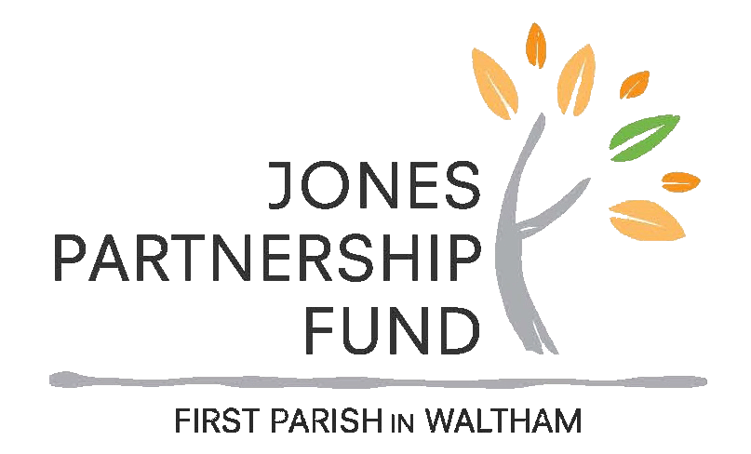
Jones Partnership Fund
Application for Funding – 2024

Request for Proposals issue date: December 10, 2023
Applications are due no later than
Thursday, February 1, 2024, 5:00 p.m.
- - - Extensions Not Permitted - - -
This form is intended to be completed on your computer, saved, and emailed.
Please name your files with your organization name and the year
(such as: "Our Organization Name Application 2024")
Print, complete and mail to FPW, 50 Church Street, Waltham MA 02452
Or complete the online form via the link on the church website.

Organization Name:
Address:
Website:
Project Name:
Project Dates: | from: |  |  |  |  |  |  |  |  | to:
Executive or Project Director: | name:
address:
(if different from above)
 | phone: |  |  |  |  |  |  |  |  |  |  | email:
Church Sponsor: | name:
 | address:
 | phone: |  |  |  |  |  |  |  |  | email:
Total Cost of Project: |  |  |  |  | $
Amount Requested from JPF: |  |  |  |  | $
Make check payable to:
Does your organization have 501(c)(3) status? |  |  |  |  |  |  |  | ☐ YES ☐ NO
If not, what organization will act as your financial agent?
Jones Partnership Fund
Funding Guidelines 2024

Intent of the Fund
The Jones Partnership Fund allows First Parish in Waltham to offer grants that support programs and projects outside its annual budget. Since its inception in 2009, the fund has supported various non-profit organizations that serve the Waltham community with grants typically in the $1000 to $2500 range. For examples of the wide variety of approved proposals, visit the church website (walthamuu.org/partnership). Partnership is central to the intent of the fund as First Parish seeks new ways to forge meaningful connections beyond the walls of the church.
When applying for the grants, avoid requesting for staff’s (members of the organization) salaries or any form of remuneration to such persons. The Committee will support, to a certain limit, requests to fund out-sourced experts if hiring them is paramount to the success of the proposed project. The Fund’s central goal is to fund programs.

Funding Criteria
Priority in approving a grant will be made according to the following criteria:
- Supports or creates partnerships within and/or outside the church community.
- Reflects Unitarian Universalist principles and values (See walthamuu.org/beliefs)
- Indicates ways to ensure measurement of success.
- The project primarily benefits the Waltham population. The organization doesn’t have to be based in Waltham, but the project needs to be beneficial to the Waltham community.

Applicants Need a Church Sponsor
- Applicants need a Church Sponsor who is at least 18 years old and has been a member of First Parish in Waltham for at least one year.
- A person or group may apply for a grant only in partnership with a Church Sponsor.

Application Process/Timeline
- Grants are disbursed on an annual basis. The application process starts on December 10, 2023 when the applications for 2024 are made available on the church website.
- Grant approval in one year does not guarantee approval in a subsequent year.
- All grant requests must use the forms available online at the church website.
- As part of our church’s green effort, we prefer that grant requests be made online. But, if your request must be submitted on paper, please supply five copies for the committee’s use.
- Assistance in making a grant request or in finding a church sponsor is available from any member of the Jones Partnership Fund Committee. Please contact the Jones Partnership Fund Committee via email at walthamuu@gmail.com if you need such assistance.
- A conformation email will be sent to the organization upon receiving its application. Please check for the “received” email and get in touch with your sponsor in case you don’t receive one by Feb. 2nd. Late applications will not be accepted.
- The deadline for receipt of all applications is Thursday, February 1, 2024 at 5:00 p.m.
- Final approval of grant requests is made by vote of the congregation at its Special Meeting in April 2024.
- Funds are available for disbursement as soon as possible after April 20, 2024.

Reporting Requirements
At the completion of the project/program, grant recipients are required to submit a brief written Final Report summarizing the outcomes of their efforts. Final Reports shall be submitted no later than December 15, 2024. No exceptions. Failure to submit a final report will negatively impact future applications.
Sponsors’ Responsibilities/ Guidelines
Each organizational applicant for a Jones Partnership grant is required to have a Sponsor from First Parish Waltham. There are several reasons for this:
- The sponsor is required to write a letter of support of the organization, to be attached to the application.
- The Sponsor represents the organization, and the organization’s project to the Jones Partnership Fund.
- A Sponsor will promote to the First Parish community the activities of that year’s project.
- The Sponsor will stay in contact with the organization and with the Jones Partnership Fund Committee on the organization’s status.
- The Sponsor will direct the organization to prominently display the Jones Partnership Logo in any materials publicizing the project or event funded.
- The Sponsor confirms that the Final Report is submitted by December 15 of the calendar year.

Please Note
- A church member may sponsor only one proposal each year.
- We will acknowledge receipt of your proposal in a timely fashion. If you do not hear from us within a reasonable amount of time, please e-mail us at walthamuu@gmail.com

* * * * * * * *

Project Description
(What is your project? Include any involvement with personnel outside of the organization. Is this a new or ongoing project?)

Serve the Community
How does your project serve the community or a special population in Waltham? What ACTION PLAN will you take that ensures partnership with the sponsor and the church?

Measure Success
How will you determine that your project is successful?

Project Budget

Project Dates: | from: |  | to:
Person Responsible for Finances: | name:
 | phone:
 | email:

Expenses
ITEM  (e.g. labor, copying, advertising) | LINE ITEM  TOTAL | AMOUNT REQUESTED  FROM JPF
TOTALS **
Income
ITEM  (e.g. individual donors, events) | LINE ITEM  TOTAL | AMOUNT PAID  BY JPF
TOTALS **

** Total Project Expenses and Total Project Income must be equal.

Budget Justification
Are income sources secured? If not, when will they be secured?

Is there anything else you would like to tell us? Please attach any support documents, e.g. (photos, letters of recommendation).

_____________________________________________________
Executive Director or Board President

_____________________________________________________ _____________________
Signature Date

Required Attachment: Letter of support from a sponsor from First Parish Waltham.

You may submit these forms via email to: walthamuu@gmail.com
Or mail to: Jones Partnership Fund, 50 Church Street, Waltham, MA 02452

OFFICE USE ONLY: Submitted by due date? __ Yes __ No

